Where Do I Belong?
By Anastasia Q., Hallandale Beach, FL
Email me when Anastasia Q. contributes work
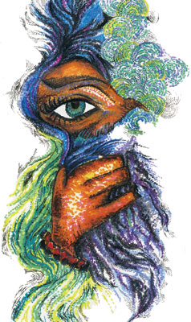
Photo credit: Alicia W., Bonita Springs, FL
A few days ago, I saw a tiny black ant making its way up the pink-tiled wall of my bathroom. Oddly amused, I watched this little creature climb up three feet and then fall to the floor. I found two things extremely shocking. First, I had never seen an ant fall; second, I was actually getting worried about the little guy, and tried to explain to him that he had to stay away from the vertical lines of grout. Never mind the fact that I was talking to an ant.
But the most amazing part was that just a second after falling from well over 500 times his height, this little genius found his way back to the wall and started climbing again. One would think that he would either hurt himself or learn a lesson, but he insisted on going up that wall again and again. And he kept falling, keeping me absolutely mesmerized, as though I had witnessed Medusa herself and not an ant, hypothesizing as to where exactly he was trying to go.
Finally, I gave up and went on to what I had to do that day. My final theory was that he was simply trying to get home, because it was already quite late, and he seemed to be scurrying along in the general direction of the crack between the window and the wall. I guess I’ll never know whether he made it.
There is, however, a point to my ant story: In the summer after sophomore year, I took a rather uncommon and extensive vacation – to a post-Communist developing country. Having been born and raised in Bishkek, the capital of Kyrgyzstan, I was, on the one hand, returning home to visit my grandparents. But as soon as my mom and I stepped into the Bishkek airport, I realized how out of place I felt.
My mom was right at home, speaking her native language with the people she spent most of her life with. But I spoke Russian hesitantly and with an accent, and insisted on talking to my mom in English. The place I had once called home had become a foreign country, and that little girl was now an American – a dreadful thing to be in a Russian-speaking Asian country.
When I returned to my now well-appreciated South Florida town, I once again felt like a stranger in a place I had called home. I realized that I wasn’t like most of my friends, who had been born in Fort Lauderdale and spent their entire childhood in the suburbs. I had come from an alien world and could never be a flag-waving American.
Sometimes, you see, I feel just like that ant on my bathroom wall. I try to get home but the world is so big and dangerous that I don’t even know where home is. Yet I keep trying and trying, no matter how many times I trip over the grout and fall to the floor, because I’m convinced that eventually I will reach a place that will really be my home – not my mother’s and not my stepfather’s, and not my best friend’s.
My visit to – and return from – Bishkek taught me, among other things, that I will never feel truly at home – either in the U.S. or in Kyrgyzstan. I realize I must let go of both the places I have called home. Caught between two cultures and belonging to neither, I have to focus not on what country I’m from or what language I speak, but on who I am. And though not belonging isn’t exactly the best teenage condition, I am beginning to understand it is actually to my advantage to be an outsider. In my cosmopolitan epiphany, I may have lost a national flag or two, but I gained something truly worthwhile – an irreplaceable freedom of the soul that can never be taken from me.
That’s not to say, however, that I’ve given up scaling that pink-tiled wall. But that little crack between the window and the wall isn’t a country or a house anymore; it’s me.

